# Report on DIY Writing Machine Built from Junk Materials

## Introduction

This report details the development of a functional writing machine constructed using discarded materials such as a non-working DVD drive, waste wood, and other salvaged components. The machine is capable of writing using a pen and operates in the XY plane, effectively replicating basic CNC-style movement for automated writing or drawing tasks.

## Materials Used

- Non-working DVD drives (repurposed stepper motors and linear rails)  
- Waste wood (used as the frame for structural support)  
- Old electronic components (Arduino, motor drivers, wires, and power supply)  
- Scrap metal and plastic parts (for mounting and adjustments)  
- Ballpoint pen holder (fabricated using recycled brackets)

- CNC shield (to interface with the Arduino for motor control)

- 9V 1A adapter (for powering the system)

- Benbox software (used for controlling the writing machine)

## Design and Construction

The writing machine was built with an XY-axis motion system, where:  
- The X-axis was created using one DVD drive’s stepper motor and linear rail.  
- The Y-axis was assembled similarly using another DVD drive mechanism.  
- A pen holder mechanism was attached to allow precise vertical movement to engage and disengage the writing surface.  
  
The system was powered by an Arduino microcontroller that controlled stepper motors using motor driver modules. The movement was programmed using G-code commands, allowing the machine to draw letters, shapes, and patterns with high accuracy.

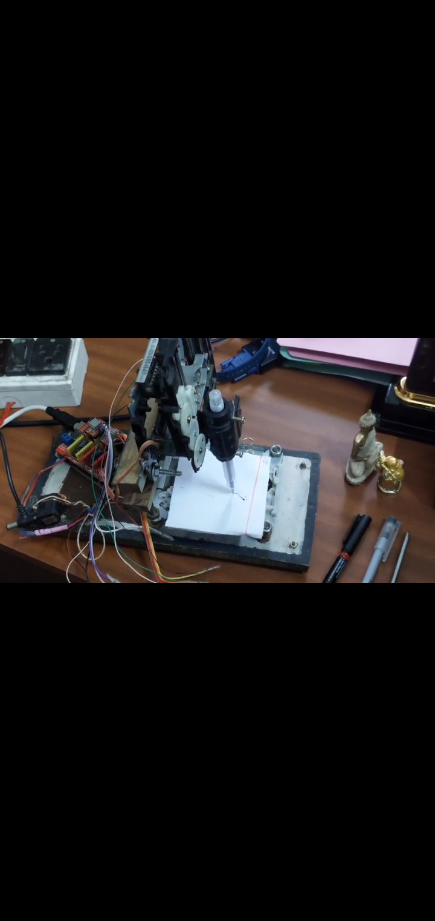

## Functionality and Performance

- Smooth movement along the X and Y axes  
- Precise pen control, allowing for clear and legible writing  
- The ability to draw patterns and letters accurately  
- Compatibility with different writing instruments, including pens, pencils, and markers

## Applications

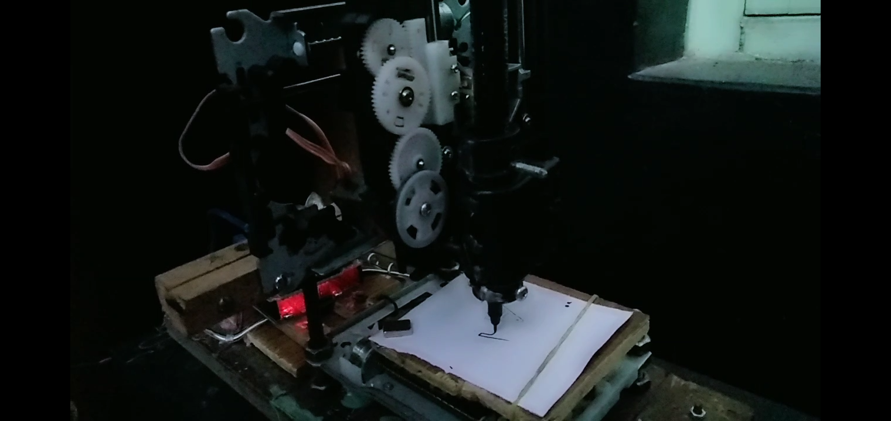

- Automated lettering and signatures  
- Basic CNC plotting and drawing  
- Educational purposes to demonstrate motion control and robotics  
- DIY projects and customized artwork

## Conclusion

This project successfully transformed waste materials into a fully functional writing machine. The device operates efficiently in the XY plane and provides an excellent example of repurposing electronic waste for practical applications. Further improvements, such as adding a Z-axis for better pen control, could enhance its functionality.

PRIYAM GHORUI

ROLL NO. UG/SOET/30/24/135

B.TECH (CSE)